**NUMBER PUZZLE:**

The Number Puzzle game can look simple but sometimes it can be impossible to solve. Especially if the matrix gets bigger. We can solve a 2x2 puzzle very easily, within 10 moves. In a 3x3 puzzle, arranging 8 numbers in ascending order while moving tiles only in horizontal or vertical positions is harder but not impossible to solve. On the contrary, solving a 4x4 puzzle can sometimes be impossible as it involves 15 numbers now.

The number puzzle game I created is not a new game. We can see similar games involving images, in an image puzzle game we must arrange the tiles such that we can form a complete picture. We have many similar games available on the internet today.

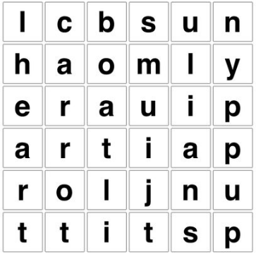

The above are image puzzle in which we have to arrange the pieces to complete the image, word puzzle in which we have to spot hidden words, and block puzzle in which we have to drag the blocks to complete a horizontal row. We can find more similar games if we search for them.

In my game, I first drew the image in word and imported it as a sprite. I sliced the picture to get 16 tiles, 15 numbers, and an empty tile. Using the grid, I placed the 16 tiles in the form of a 4x4 matrix. Now I added movement and sliding effect to the tiles when we click on them. The tile replaces the empty tile and only the tiles around the empty tile can move. I wrote a new function to shuffle tiles and arrange them in random order. The goal of the game is to arrange the tiles in random order. To make it more interesting I placed a constraint that we should complete the puzzle in 30 moves. When we run out of moves a game over text will be displayed and a restart button if we want to play the game again. To finish it off I added a title screen consisting of the game logo and a play button. Now when we restart the game it takes us to our title screen again.

Puzzles are a fun way to pass the time. Number puzzles are classic math puzzles. We can challenge our logic and brain while having fun and enjoying.